UNIT TEST CASE :
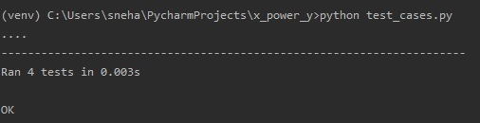

PEP-8 :
- PEP-8 for the module function_x_power_y
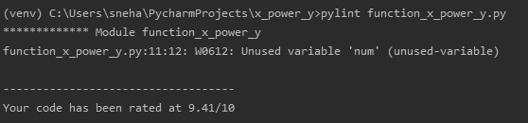

- PEP-8 for the unit test case file
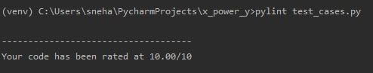

CODE COVERAGE :
